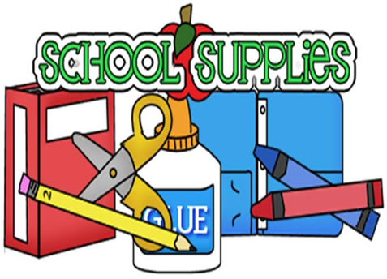
T/TH School Supply List
*2 bottles of hand soap
*Clorox wipes (if you are able to find)
*Bleach (1 liter ideally)
*2 in. binder (label name on spine of binder)
*Protector sheets (50)
*Markers (washable, classic “fat”)
*Box of crayons (“fat”)
*Glue bottle
*Dry erase markers (fat ones)
*Garbage bags (tall ones)
*Watercolor paint (labeled with child’s name)
*One ream of white paper
*2 pk of paper towels
*2 snacks per child (10 students per snack) brain food encouraged (raisins, granola bars, fruit cups, applesauce, cheese and crackers package, animal crackers) **NO PEANUTS OR NUTS**
*Slippers to be worn indoors
*Change of clothes in a gallon bag
*Large (shoe box size) Tupperware container for school supplies

Optional list:
*Food coloring *Beads
*Pipe cleaners *Google eyes
*Rice *Glitter
*Gift cards (Dollar Tree, Wal-Mart, Service Foods)

